# Problem 1

## A

L = [4, 3, 7, 6, 5, 2, 4, 1, 0, 7]

Step (Splitting):  
 [4,3,7,6,5] [2,4,1,0,7]

[4,3] [7,6,5] [2,4] [1,0,7]

[4] [3] [7][6,5] [2][4] [1][0,7]

[4] [3] [7][6][5] [2][4] [1][0][7]

Step(Comparison and merging):

[3][4] [7][5,6] [2][4] [1][0,7]

[3,4] [5,6,7] [2,4] [0,1,7]

[3,4,5,6,7] [0,1,2,4,7]

Sorted = [0,1,2,3,4,4,5,6,7,7]

## B

[4,3,7,6,5] = 1 [2,4,1,0,7] = 2

[4,3] = 3 [7,6,5] = 4 [2,4] = 5 [1,0,7] = 6

[4] [3] = 8 [7][6,5] = 10 [2][4] = 12 [1][0,7] = 14

[4] [3] = 16 [7][6][5] = 19 [2][4] = 24 [1][0][7] = 27

Total number of inversions = 27

## C

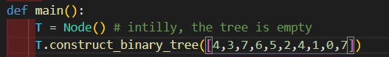

Postorder for L

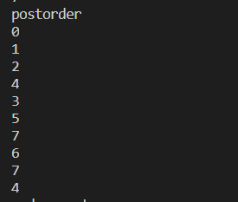

# Problem 3

Reconstructed Expression: $$[a*\left\{b**\left(c+d\right)\right\}-[e+\left\{f*\left(g**h\right)\right\}]$$